Product Page -

* **Remove rounded corners**
* **Input of a specific amount is not possible (also if for example if i select 10 on this product, the price goes to zero -** [**https://demoworksite.online/de/product/4029?v=27279**](https://demoworksite.online/de/product/4029?v=27279)**)**
* **Loading time with color selection is very long - Needs to be in fraction of a second**
* **A lot of products that don’t have any variations, still do have dropdown menus == Working well for me, If you can see this problem then please share the product url**
* **Some variations have the same/wrong picture (**[**https://demoworksite.online/de/product/4416**](https://demoworksite.online/de/product/4416) **////** [**https://demoworksite.online/de/product/4411**](https://demoworksite.online/de/product/4411)**) ===== Both product has ‘SCHWARZ’ color in common, so same color image is displaying. Any products which have common colors will display the same color-images**
* **On a few products the info is in dutch**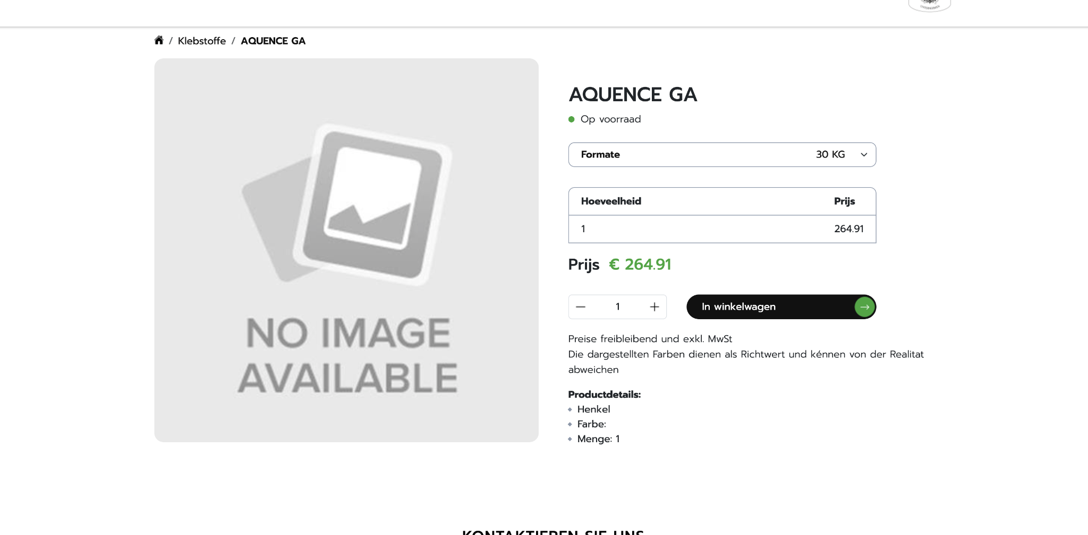
* **Also, product details must show the information of specification selected for an item.**

**https://demoworksite.online/de/product/4021?v=27229**

**This product has following specifications,**

**- Formate,**

**- Materiaaldikte**

**- Menge**

**But it is showing this,**

**Produktdetails:**

**Foam-X - This is correct**

**Farbe: - This is not**

**Menge: 12**

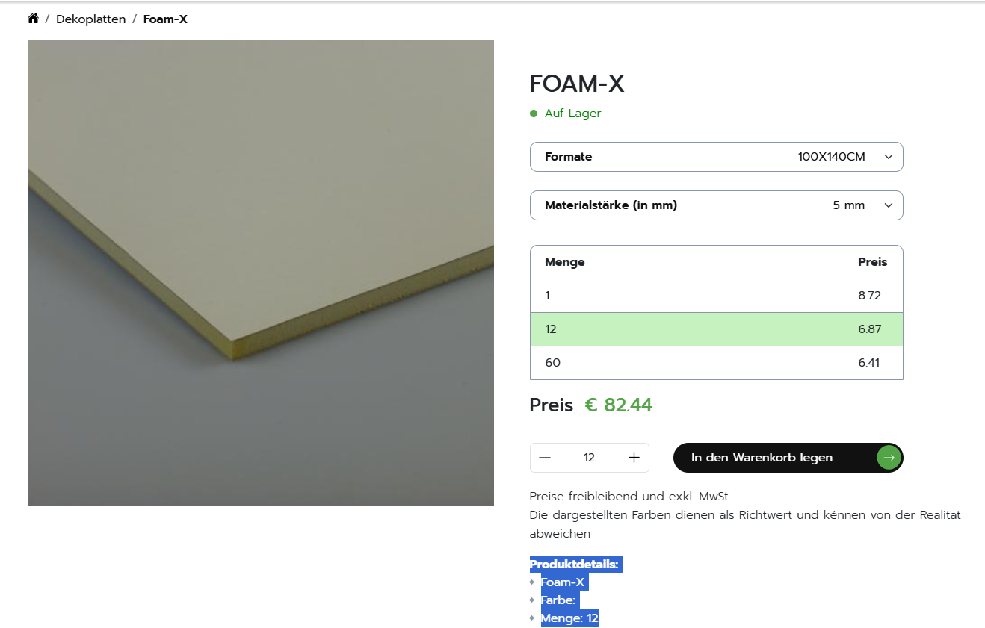

* **https://demoworksite.online/manufacture/Moorman all manufacture page has English text - "Manufactured By". It should be in German in all manufacture pages.**
* **Can we have a “,” instead of a period to separate the price? i.e. 12,50€**
* **“Die dargestellten Farben dienen als Richtwert und können von der Realität abweichen.” - that is the correct sentence. It is missing the Umlauts in the current versions**
* **Change this “Wählen Sie Format: 100CM50LFM” to “Format: 100CM50LFM”**
* This price is only available at 5 units. Why is that? == It is working well. (<https://demoworksite.online/de/product/4429?v=29357>)   
  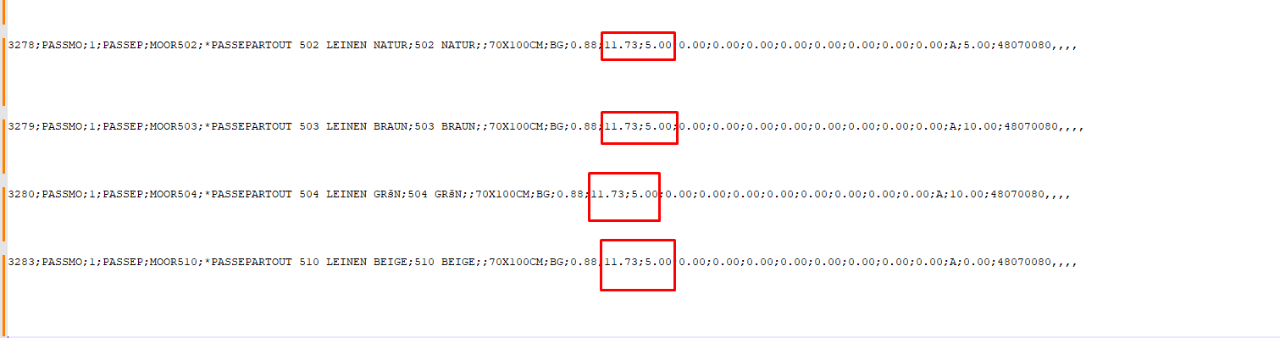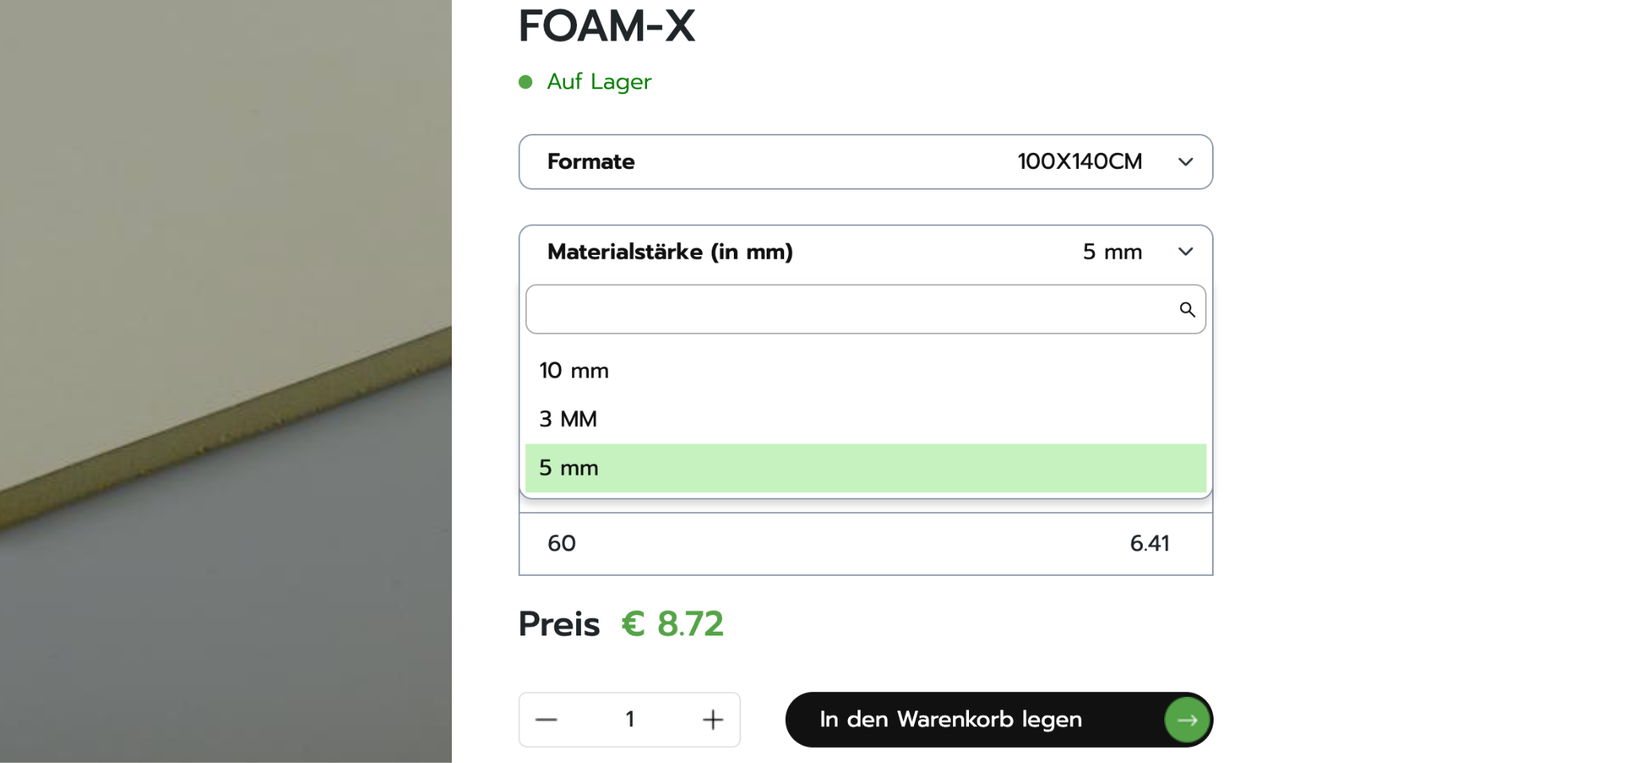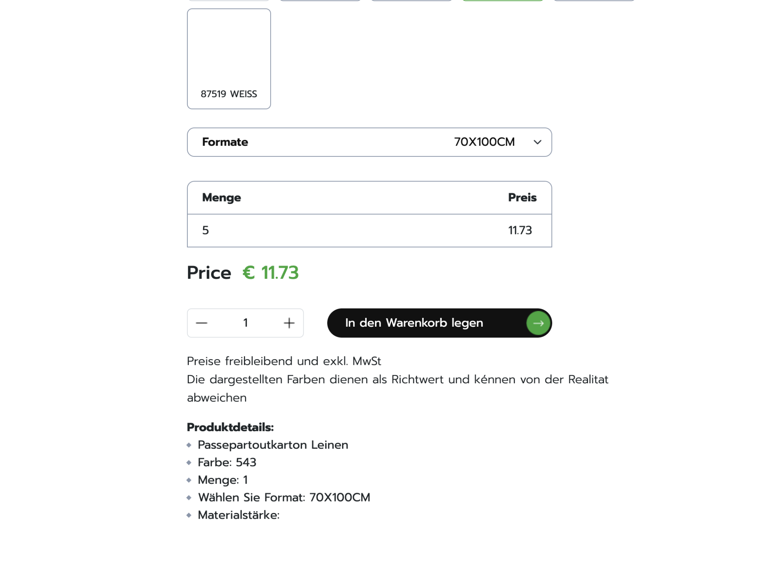
* **This product has different units (once it is 3mm and once it is 5MM) please keep it in lower case**

**(**[**https://demoworksite.online/de/product/4021?v=27229**](https://demoworksite.online/de/product/4021?v=27229)**)**

* **This product starts at Price Tier 0€ . Does not make sense   
  (**[**https://demoworksite.online/de/product/3901?v=25445**](https://demoworksite.online/de/product/3901?v=25445)**)**
* [**https://demoworksite.online/de/product/4184**](https://demoworksite.online/de/product/4184) **Product missing variation**
* **Please add product variation name (i.e SPEZIALPAPIER SELBSTKL. WEISS) under each product title  
  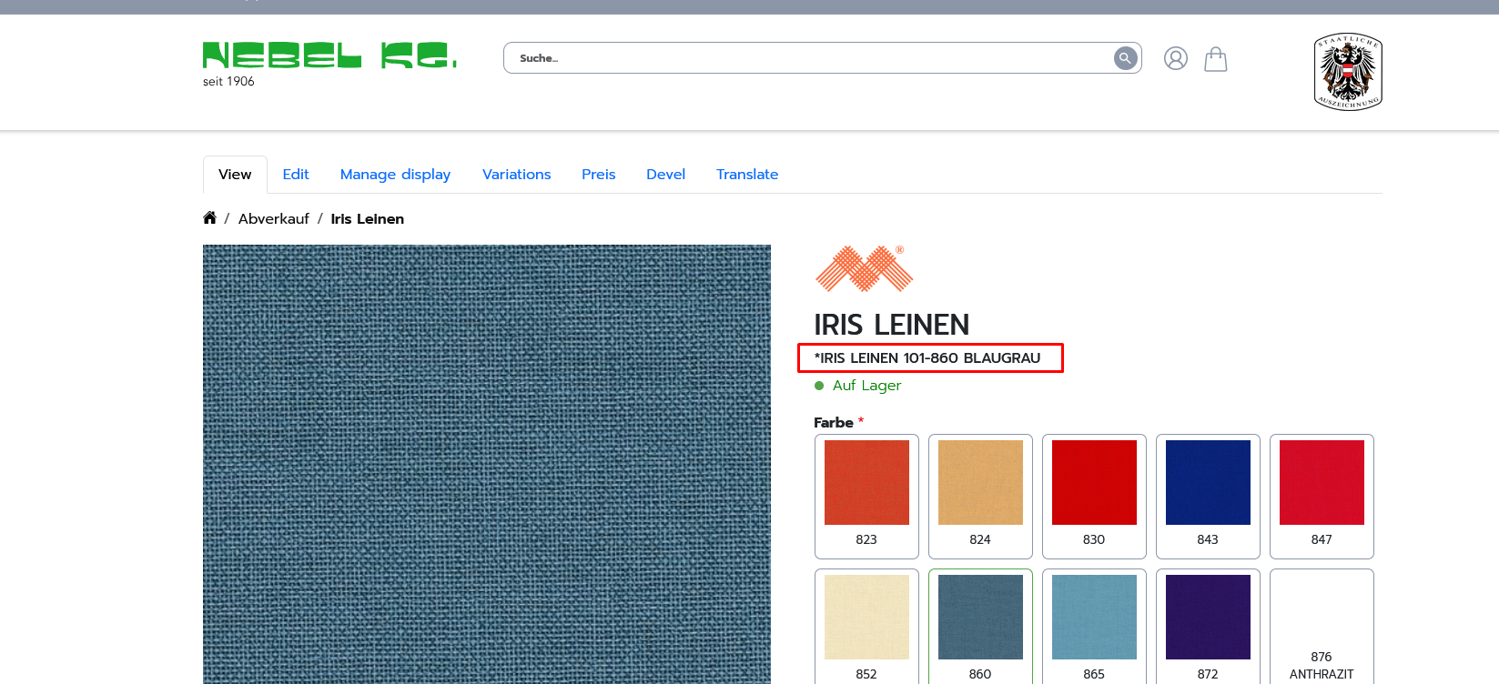**
* **26/12/2024 - Mayank > Spelling mistake with comparison to excel sheet.**

**(**[**https://demoworksite.online/de/product/6108?v=40602**](https://demoworksite.online/de/product/6108?v=40602)**)**

**Answer:** 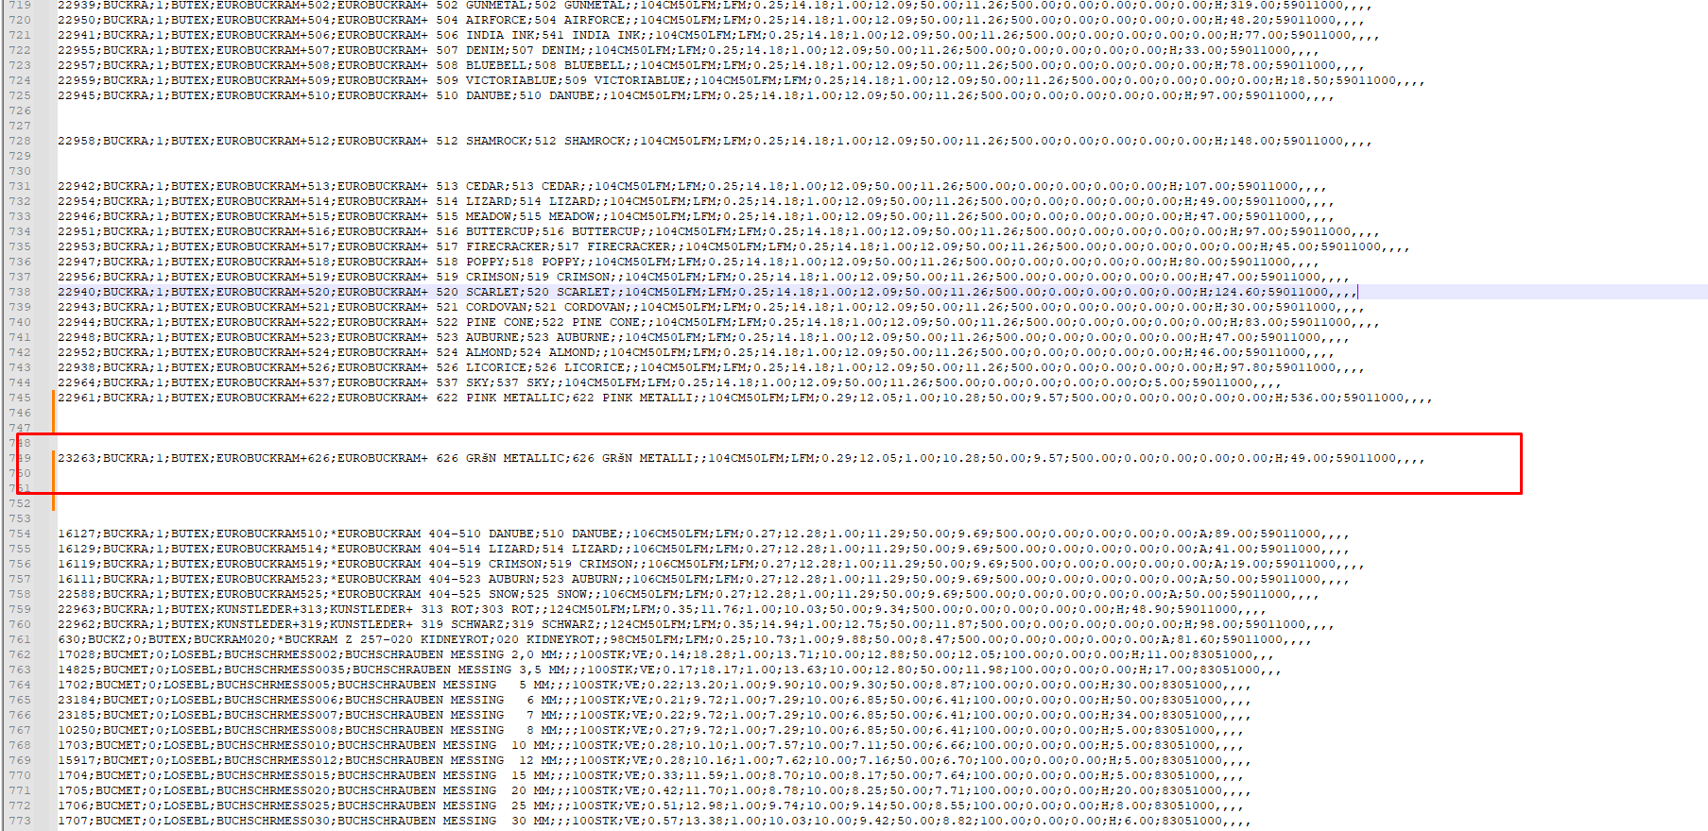

**This happened because of mis-spelled data in updator sheet, it updated the imported data, that was the work of updator.**

****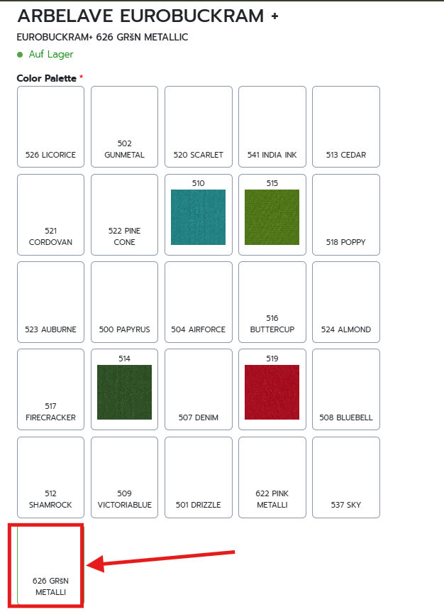

* **26/12/2024 - Mayank > There is no material thickness in this product.**

**(**[**https://demoworksite.online/de/product/6108?v=40602**](https://demoworksite.online/de/product/6108?v=40602)**)**

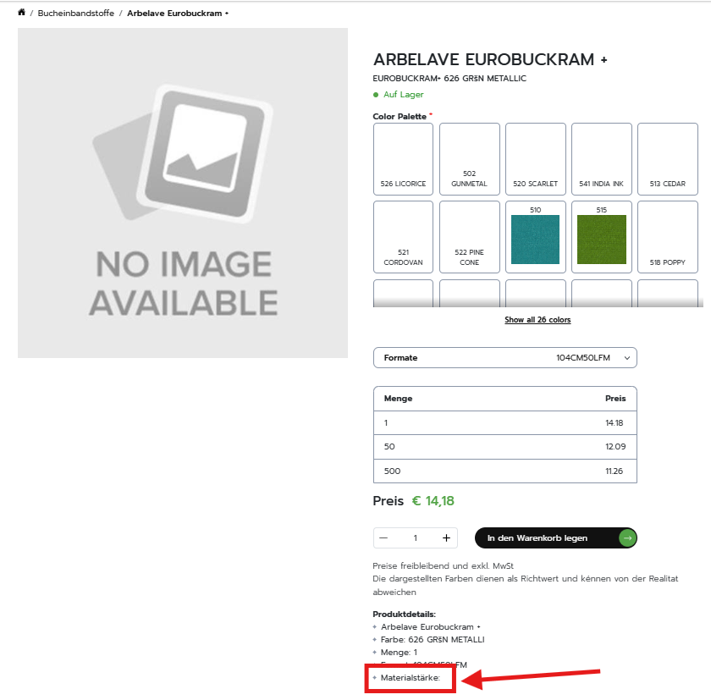

* **26/12/2024 - Mayank > Product category is incorrect (**[**https://demoworksite.online/de/product/6109**](https://demoworksite.online/de/product/6109)**)**

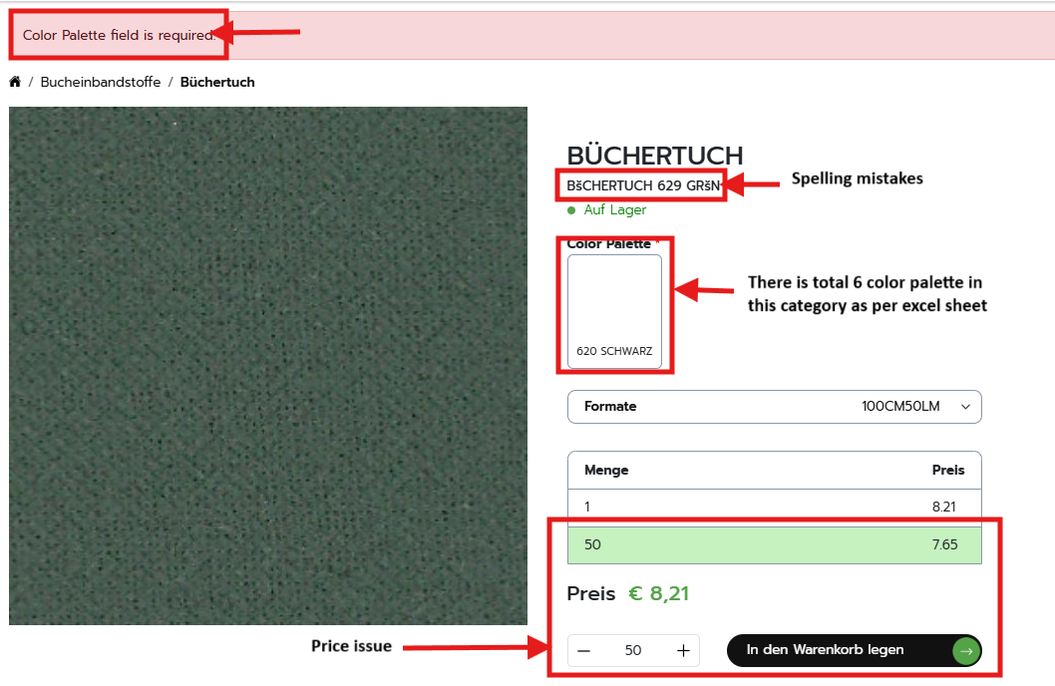

**Answer:**

**For Color Palette field is required === DONE**

**For mis-spelled variation name:** In the updator sheet, this variation name is added

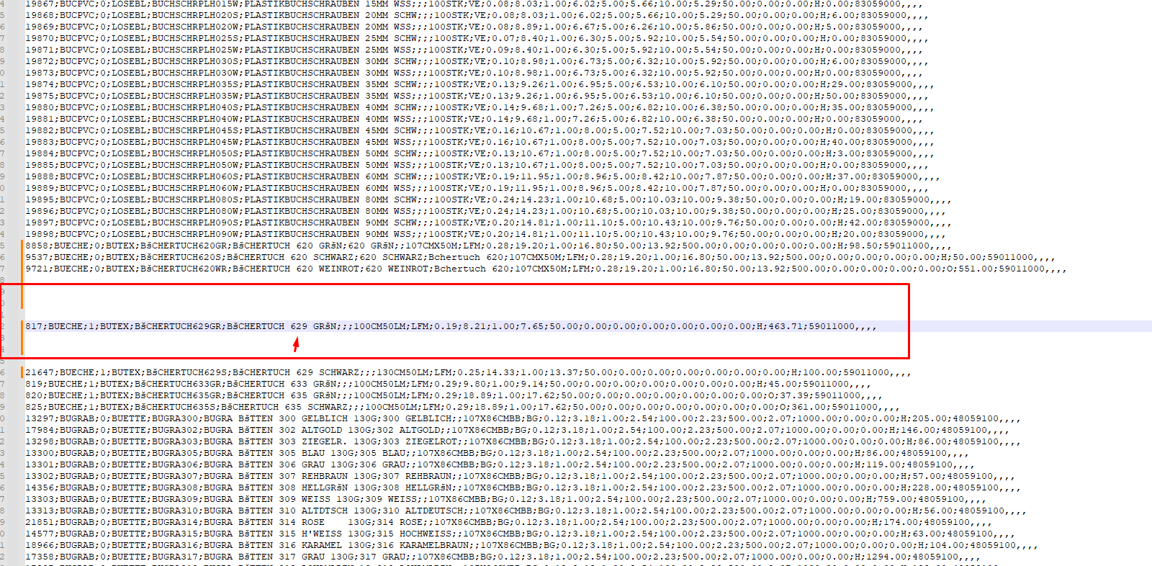

**For Color palette issue:**  
In the importer sheet, this product has 2 color variations and in updator sheet there is no color data added, so it removed the color. Only one variation of this product (SKU: 9537) has color data added in updator sheet so one color palette is displaying.

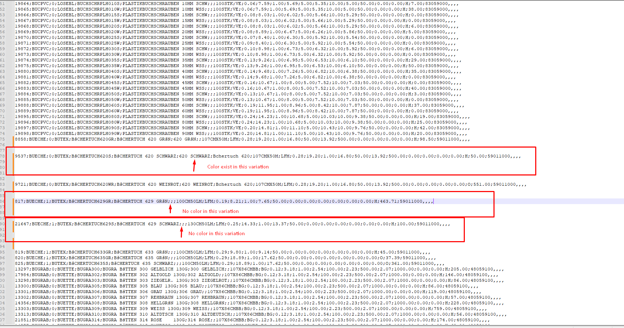

**Answer for Product category is incorrect:**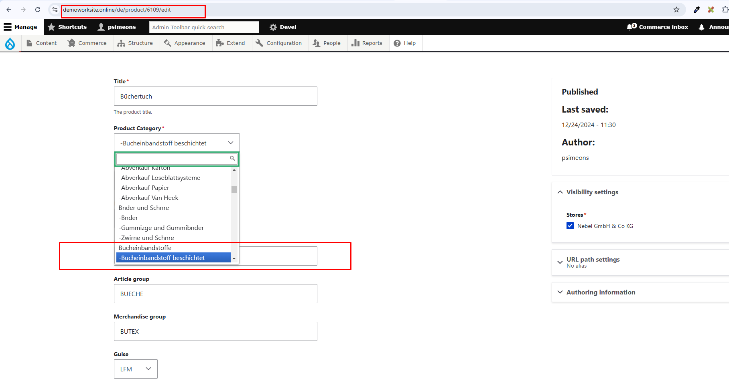

The category assigned to the product is same as the record in excel sheet

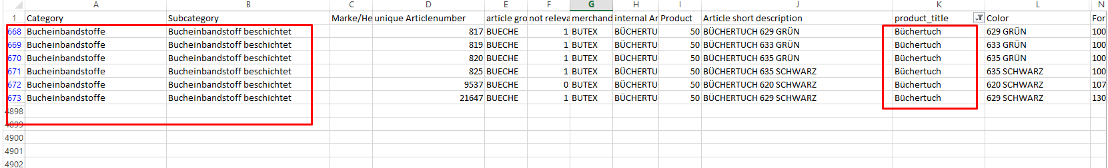

* **26/12/2024 - Mayank > In this product some color palette inside a box name is downward and some name is upward and some name is only color number without a name. please arrange the text alignment inside every box following the same pattern. Please check every product category. (**[**https://demoworksite.online/de/product/6110?v=40613**](https://demoworksite.online/de/product/6110?v=40613))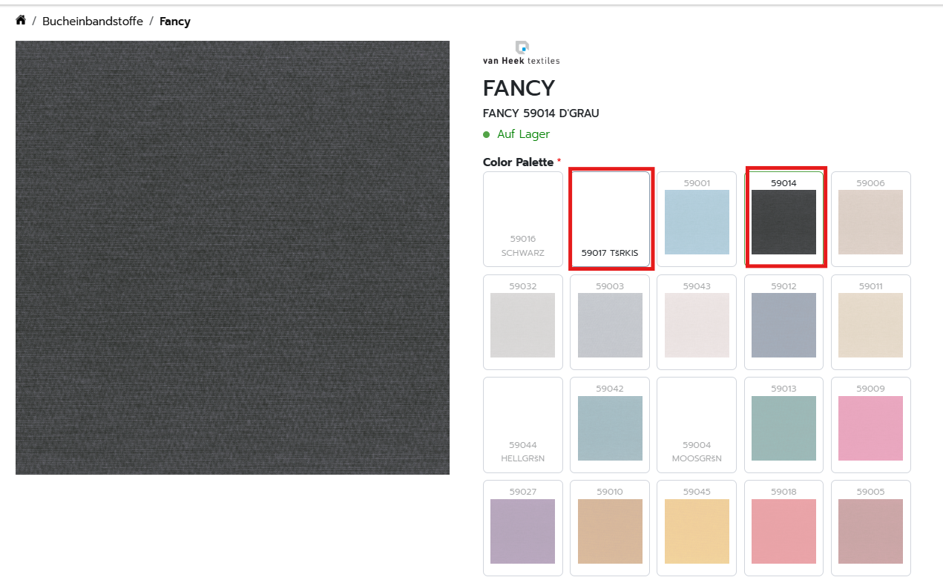

**==== DONE**

* **26/12/2024 - Mayank > I noticed the same pattern running through the descriptions of each product. Whatever is in detail in the product should be in the product detail. Please check every product category. (**[**https://demoworksite.online/de/product/6767**](https://demoworksite.online/de/product/6767)**)**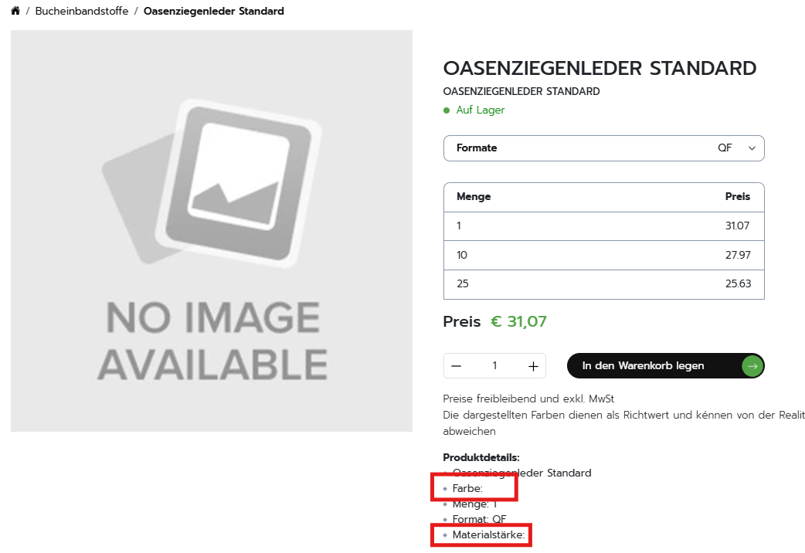
* **26/12/2024 - Mayank > Price issue. Please check every product for this type of issue. (**[**https://demoworksite.online/de/cart**](https://demoworksite.online/de/cart)**)**

**=== DONE**

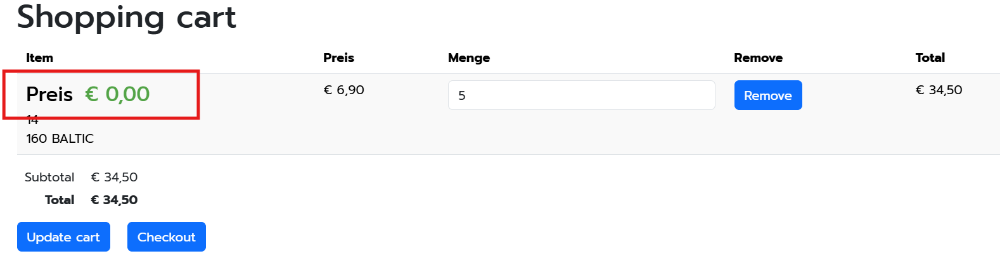

**=== DONE**

* **26/12/2024 - Mayank > Can you please remove farbe and material thickness in the product detail and add here type. (**[**https://demoworksite.online/de/product/6434**](https://demoworksite.online/de/product/6434)**)**

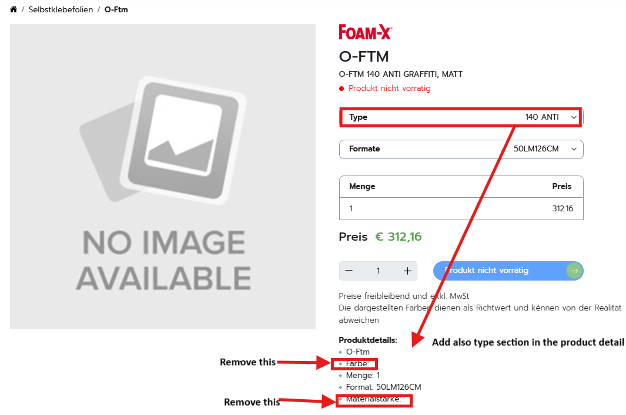

**== Done**

* **26/12/2024 - Mayank > We are not able to add more than 1 quantity of products to the cart. (**[**https://demoworksite.online/de/product/6384**](https://demoworksite.online/de/product/6384)**)**

Answer: More than one quantity of a product in cart is adding, it would not be added in case when product will be out of stock

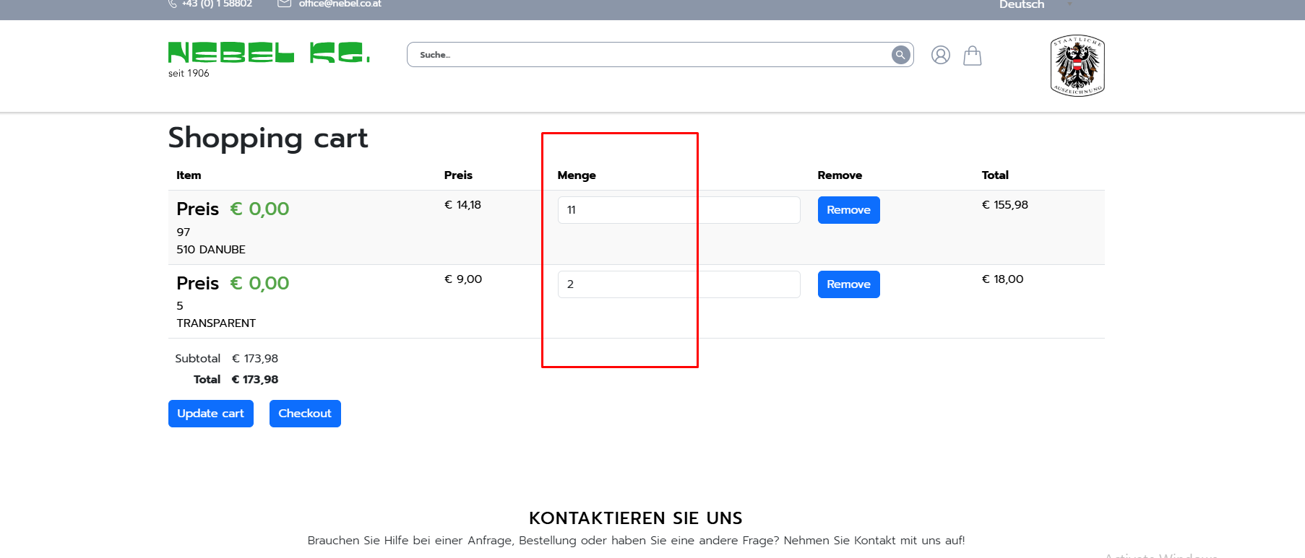

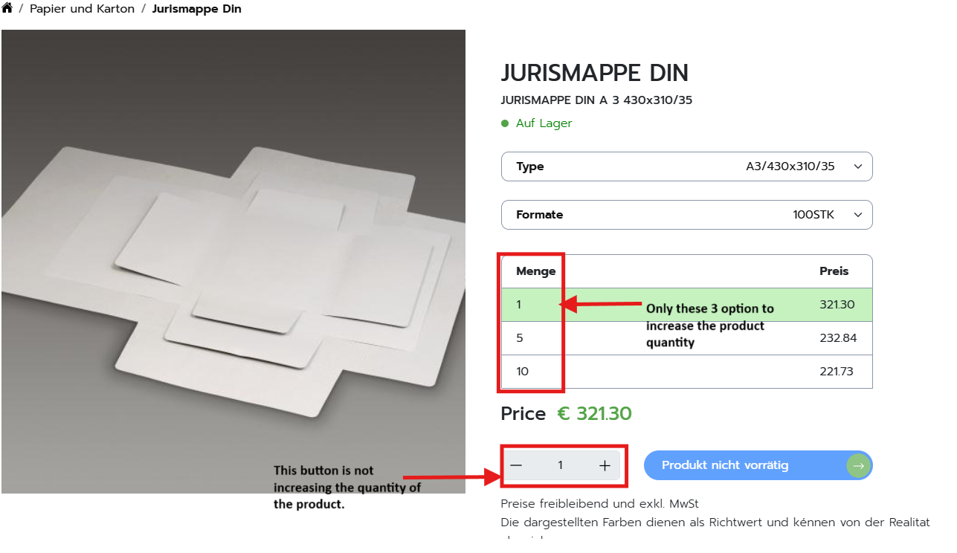

Answer: Quantity value not increasing due to out of stock product.

* **26/12/2024 - Mayank > Price and quantity issue. (**[**https://demoworksite.online/de/product/6653**](https://demoworksite.online/de/product/6653)**)**

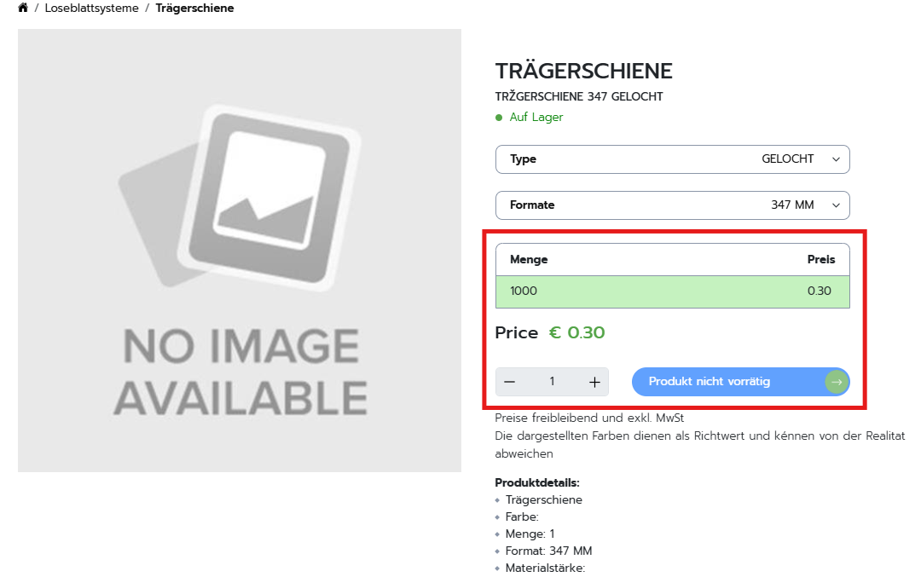

Answer: Since 1 quantity and price is added , so In this case: for quantity 1 to n, per quantity price will be 0.30.

* **26/12/2024 - Mayank > Error found (**[**https://demoworksite.online/de/product/6331**](https://demoworksite.online/de/product/6331)**). This type of problem in some** 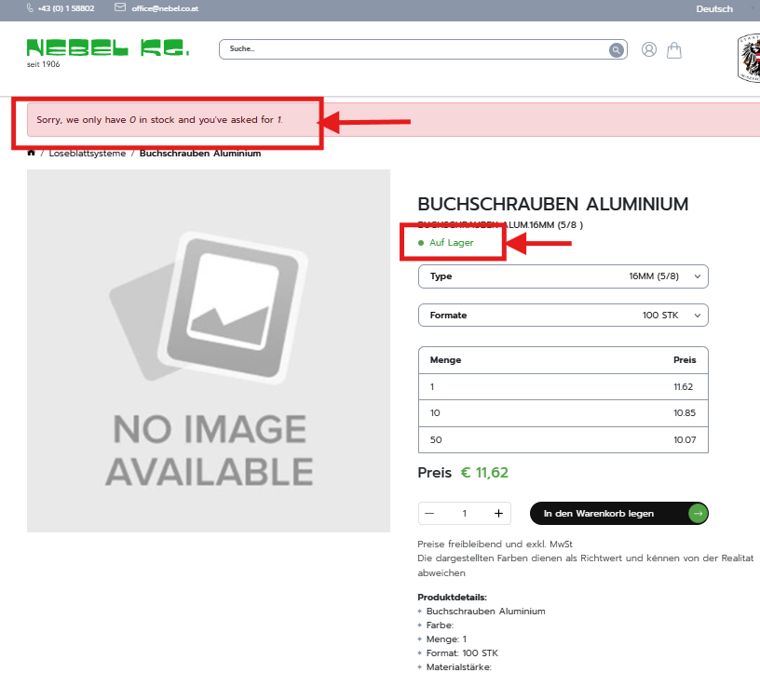

**products also please check.**

**But in the same product we have changed the language deutsch to english. The error message does not show. (**[**https://demoworksite.online/en/product/6331**](https://demoworksite.online/en/product/6331)**)**

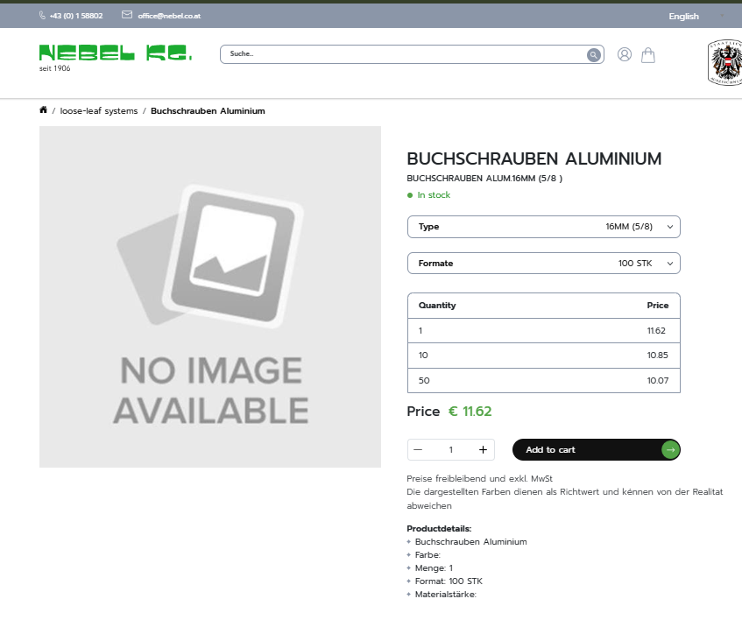

**===== NEED TO DISCUSS, ERROR IS NOT SHOWING HERE**

* **26/12/2024 - Mayank > Spelling mistake. (**[**https://demoworksite.online/de/product/6176**](https://demoworksite.online/de/product/6176)**)Please check this type of problem in every product. Only in german text.**

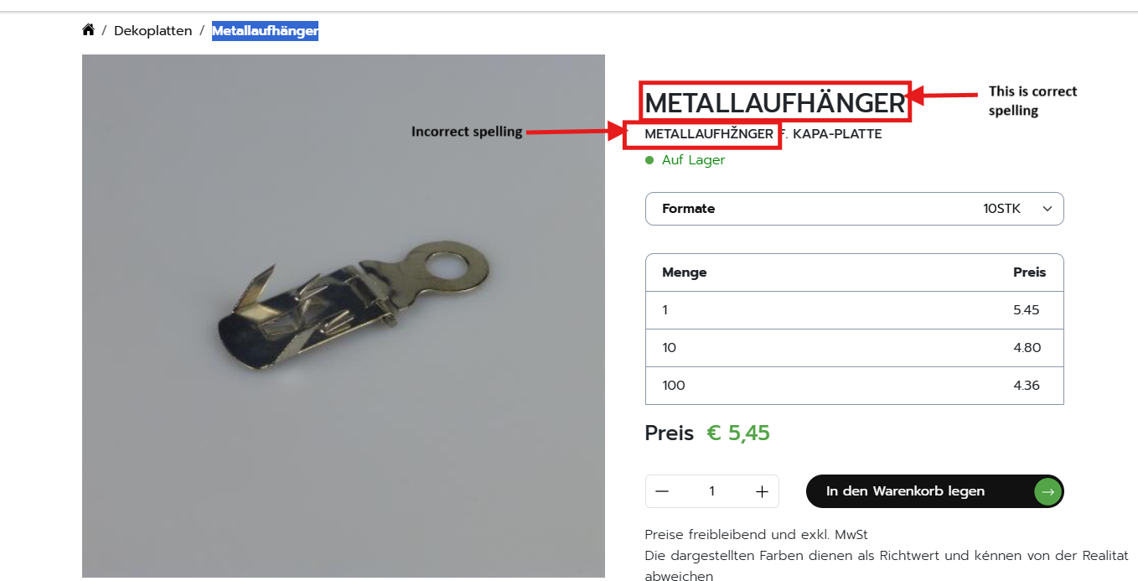

**Answer: The displaying variation title is in updator sheet**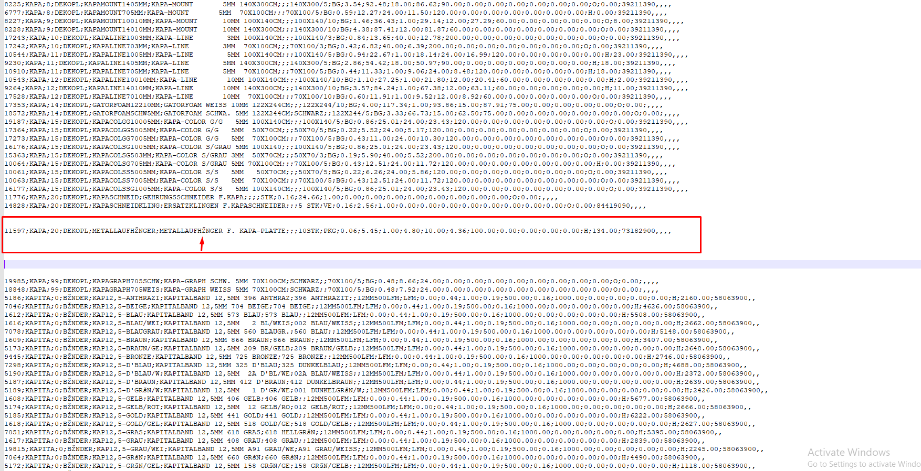

* **26/12/2024 - Mayank > Product detail missing. (**[**https://demoworksite.online/de/product/6166**](https://demoworksite.online/de/product/6166)**). In sub category Schaumstoffplatten (**[**https://demoworksite.online/de/product-list/dekoplatten**](https://demoworksite.online/de/product-list/dekoplatten)**) in every product material thickness is missing**

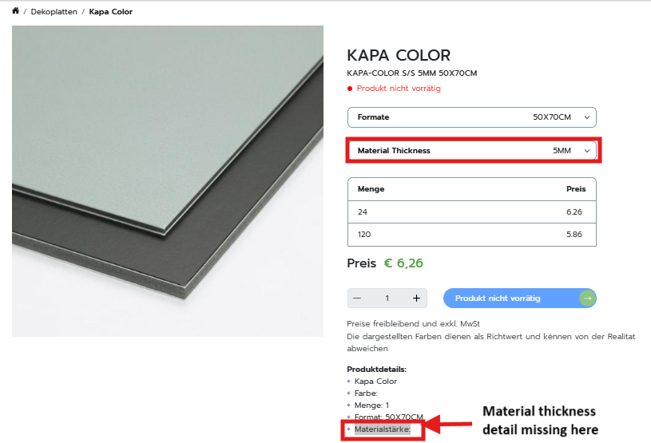

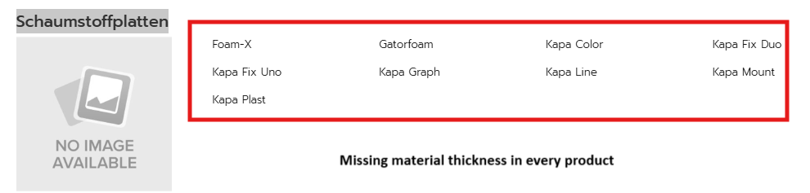**=== Done**

* **26/12/2024 - Mayank > Product detail missing. (**[**https://demoworksite.online/manufacture/Orafol**](https://demoworksite.online/manufacture/Orafol)**). Please check every product category for missing material thickness related.**

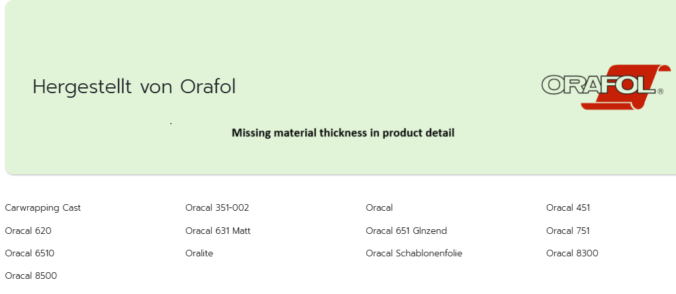

**== Done**

* **26/12/2024 - Mayank > Spelling mistake in both two different spellings. Which one is correct ? (**[**https://demoworksite.online/de/product/6606**](https://demoworksite.online/de/product/6606)**)Please check every category product.**

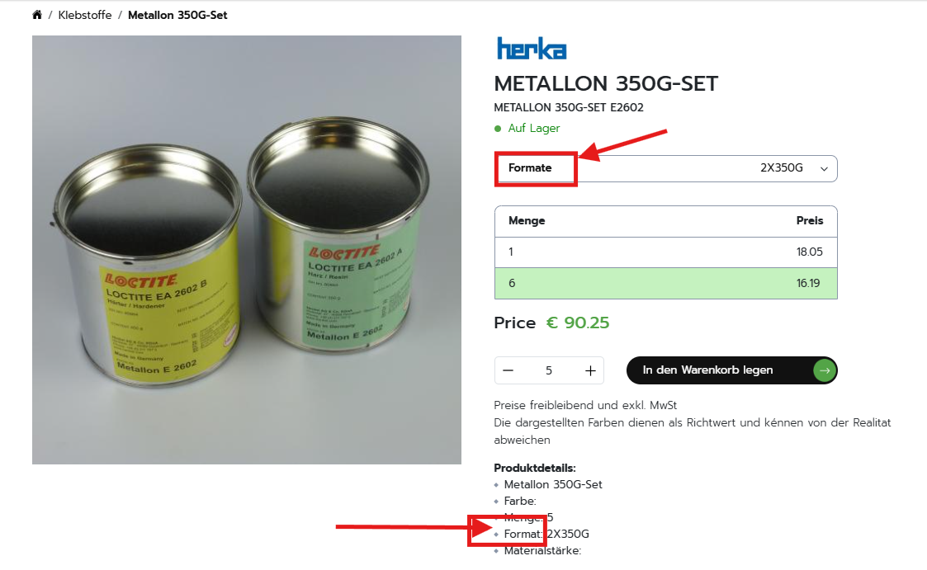

**==== DONE**

* **26/12/2024 - Mayank > Can we have a “,” instead of a period to separate the price? i.e. 12,50€ . Please check every product. (**[**https://demoworksite.online/de/product/6165**](https://demoworksite.online/de/product/6165)**)**

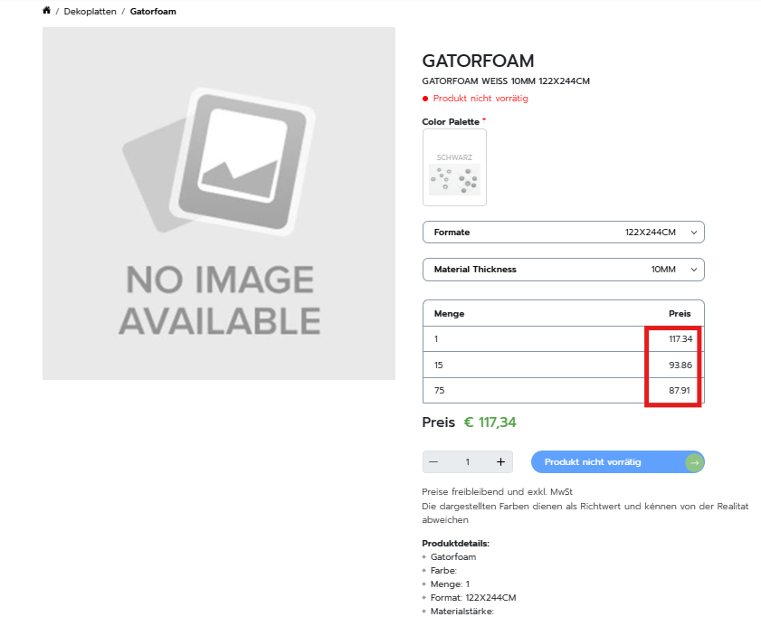

==== **DONE**